Assignment 3: Well Architected Framework for mapping the Gartner KPIs

As a Cloud Architect, you have been tasked with mapping the Key Performance Indicators (KPIs) from Gartner DevSecOps KPIs to KPIs relevant to the e-commerce industry. Your goal is to create a set of microservices that will help to achieve these KPIs.

Instructions:

1. Review the Gartner DevSecOps KPIs: Take time to familiarize yourself with the Gartner DevSecOps KPIs, such as MTTD, MTTV, Cost per Transaction, Cost of Change/Release, Incidents, Technical Debt, Production Support to Lead Time, Customer Satisfaction, Response time, Earnings, Cash Flow, Release cadence, Epic delivered.
2. Identify the relevant KPIs for e-commerce: Identify which of the Gartner DevSecOps KPIs are most relevant to the e-commerce industry. Consider factors such as customer experience, website performance, transaction volume, and revenue.
3. Map the KPIs to microservices: Once you have identified the relevant KPIs for e-commerce, map them to specific microservices that will help achieve those KPIs. For example, a microservice that improves response time or a microservice that reduces technical debt.
4. Evaluate the effectiveness of the microservices: As you develop the microservices, evaluate their effectiveness in achieving the KPIs. Use tools such as A/B testing, performance monitoring, and user feedback to measure the impact of the microservices.
5. Iterate and improve: Based on your evaluations, iterate and improve the microservices to further improve their effectiveness in achieving the KPIs.

## Deliverables:

1. A report outlining the relevant KPIs for e-commerce and their importance.
2. A map of the KPIs to microservices.
3. A plan for evaluating the effectiveness of the microservices.
4. A plan for iterating and improving the microservices based on evaluation results.

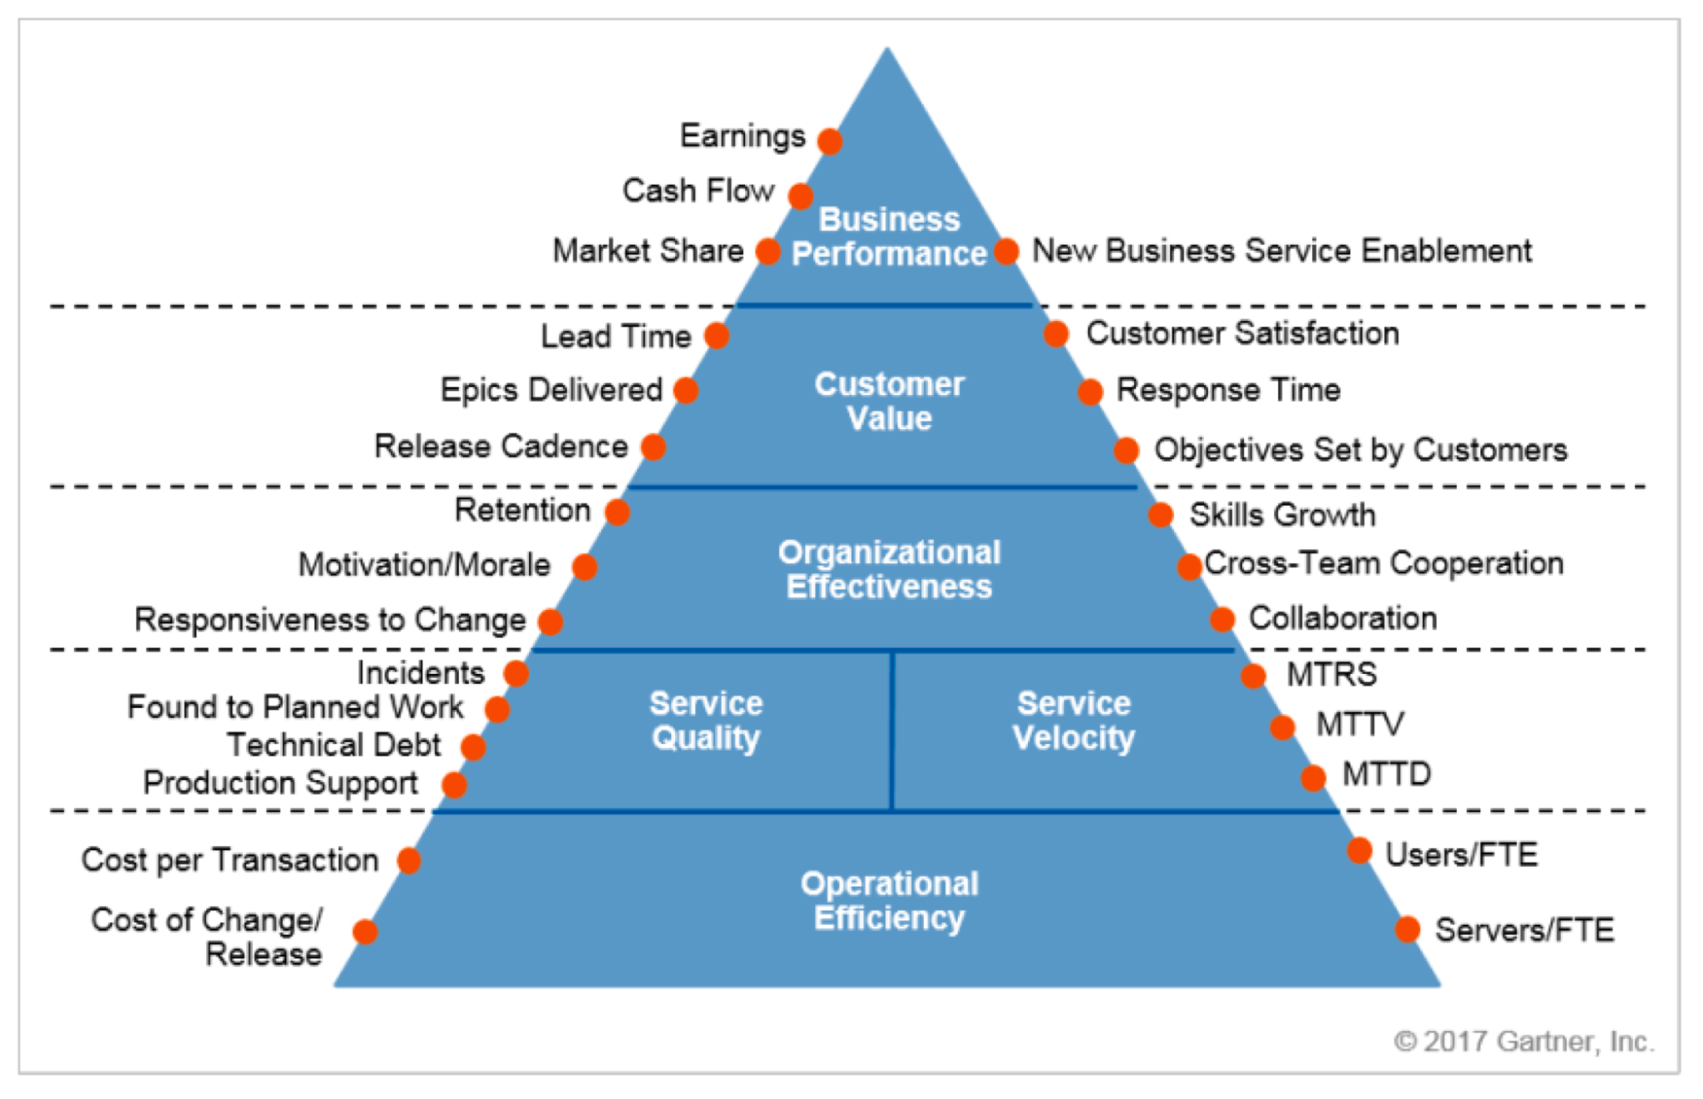

## Questions to ask:

1. What are the current KPIs being tracked by the e-commerce company?
2. What are the current pain points in the software development process?
3. What are the business goals and objectives for the e-commerce company?
4. What are the current DevSecOps practices in place?
5. What are the current monitoring and alerting systems in place?

## Checklist:

1. Identify the key KPIs for the e-commerce company and understand how they relate to business objectives.
2. Evaluate the current software development process and identify pain points and areas of improvement.
3. Understand the current DevSecOps practices and identify areas for improvement.
4. Map the KPIs from the Gartner DevSecOps KPIs to the e-commerce company's KPIs and identify any gaps.
5. Determine the appropriate microservices architecture to address the identified pain points and meet the business goals and objectives.
6. Define the appropriate monitoring and alerting systems to ensure the microservices architecture is meeting the KPIs and business goals.
7. Develop a plan for implementing the microservices architecture and monitoring and alerting systems.
8. Define the appropriate metrics and dashboards to track progress towards the KPIs and business goals.

## KPIs:

1. MTTD (Mean Time To Detect): This measures the time it takes to detect a security incident. The goal is to minimize this time to reduce the potential impact of security incidents.
2. MTTV (Mean Time To Vulnerability): This measures the time it takes to fix vulnerabilities once they are detected. The goal is to minimize this time to reduce the risk of exploitation.
3. Cost per Transaction: This measures the cost of processing each transaction on the e-commerce platform. The goal is to minimize this cost to maximize profitability.
4. Cost of Change/Release: This measures the cost of making changes or releasing new features on the e-commerce platform. The goal is to minimize this cost to maximize profitability.
5. Incidents: This measures the number of incidents that occur on the e-commerce platform. The goal is to minimize the number of incidents to maximize customer satisfaction.
6. Technical Debt: This measures the amount of technical debt that has accumulated on the e-commerce platform. The goal is to minimize technical debt to reduce the risk of future issues.
7. Production Support to Lead Time: This measures the time it takes to resolve production issues. The goal is to minimize this time to maximize customer satisfaction.
8. Customer Satisfaction: This measures customer satisfaction with the e-commerce platform. The goal is to maximize customer satisfaction to increase customer loyalty.
9. Response Time: This measures the response time of the e-commerce platform. The goal is to minimize response time to maximize customer satisfaction.
10. Earnings: This measures the earnings generated by the e-commerce platform. The goal is to maximize earnings to increase profitability.
11. Cash Flow: This measures the cash flow generated by the e-commerce platform. The goal is to maximize cash flow to ensure financial stability.
12. Release Cadence: This measures the frequency of releases on the e-commerce platform. The goal is to increase release cadence to provide customers with new features and updates more frequently.
13. Epic Delivered: This measures the number of epics delivered on the e-commerce platform. The goal is to increase the number of epics delivered to improve the platform's functionality and customer experience.

To create microservices, the e-commerce company can map these KPIs to specific microservices that contribute to their achievement. For example, a microservice focused on security could contribute to achieving MTTD and MTTV goals, while a microservice focused on transaction processing could contribute to achieving the Cost per Transaction goal. By mapping KPIs to microservices, the e-commerce company can better understand which microservices are contributing the most to their overall success and prioritize development efforts accordingly.

## Steps to KPIs

To map the KPIs from Gartner DevSecOps KPIs to business metrics, the following steps can be taken:

1. Identify the DevSecOps KPIs relevant to the e-commerce company's microservices architecture, based on the specific needs and priorities of the organization.
2. Define the business metrics that align with each DevSecOps KPI, in order to measure the impact of microservices on the company's key performance indicators.
3. Establish baseline measurements for each KPI and business metric, to track progress over time and identify areas for improvement.
4. Set targets and thresholds for each KPI and business metric, to ensure that the microservices architecture is meeting the company's goals and delivering value to the business.
5. Monitor the KPIs and business metrics regularly, using automated tools and dashboards, to identify trends and anomalies and take corrective action as needed.
6. Continuously optimize the microservices architecture based on the insights gained from the KPIs and business metrics, in order to drive continuous improvement and business value.

Some example questions and checklist items that could be used for this assignment are:

* Which DevSecOps KPIs are most relevant to the e-commerce company's microservices architecture, based on the organization's goals and priorities? Some potential KPIs to consider might include:
  + Mean Time to Detect (MTTD)
  + Mean Time to Verify (MTTV)
  + Cost per Transaction
  + Cost of Change/Release
  + Incidents
  + Technical Debt
  + Production Support
* What are the business metrics that align with each DevSecOps KPI, in order to measure the impact of microservices on the company's key performance indicators? For example:
  + **MTTD might map to Lead Time, or the time it takes to get a feature from idea to production**
  + **MTTV might map to Customer Satisfaction, or how satisfied customers are with the quality of the software**
  + **Cost per Transaction might map to Earnings or Cash Flow, or how much revenue the company is generating from each transaction**
  + **Cost of Change/Release might map to Release Cadence, or how frequently the company is able to deploy new features or updates**
  + **Incidents might map to Response Time, or how quickly the company is able to respond to and resolve incidents**
  + **Technical Debt might map to Quality or Stability, or how stable and reliable the software is over time**
  + **Production Support might map to Customer Support or Retention, or how well the company is able to support customers after the sale**
* What are the current baseline measurements for each KPI and business metric? How will these be tracked over time, and what tools and metrics will be used to monitor them?
* What are the targets and thresholds for each KPI and business metric? How will these be established and communicated to the organization, and how will progress towards these goals be measured and reported?
* What tools and dashboards will be used to monitor the KPIs and business metrics? How will these be integrated into the company's existing DevOps and ITSM processes, and how will alerts and notifications be managed in the event of anomalies or deviations from the established thresholds?
* How will the microservices architecture be continuously optimized based on the insights gained from the KPIs and business metrics? What processes and tools will be used to capture feedback and iterate on the architecture, and how will these be integrated into the company's existing DevOps and ITSM processes?